**Assignment #2**

Design an interface for a scholarship search engine

By: Cole Beck, Byeonghyeon Choi, and Elizabeth Dayton

Scenario

User Craig Gregory plans to use this system to find and apply for as many scholarships as he can. He will first land on a welcome page with various relevant links to begin him on his search for scholarships. He will be able to join as a member of the website so that he can enter relevant information about himself so that scholarships are automatically filtered to what he qualifies for. This information will include: his name, birthdate, gender, ethnicity, address, which high school he attended, which year he will graduate or has graduated high school, his highest level of school completed, GPA, ACT and/or SAT scores, planned major, parents marital status, parents highest level of education completed, household income, household size. After joining, he will be able to search through and apply for scholarships the system has predetermined his eligibility for.

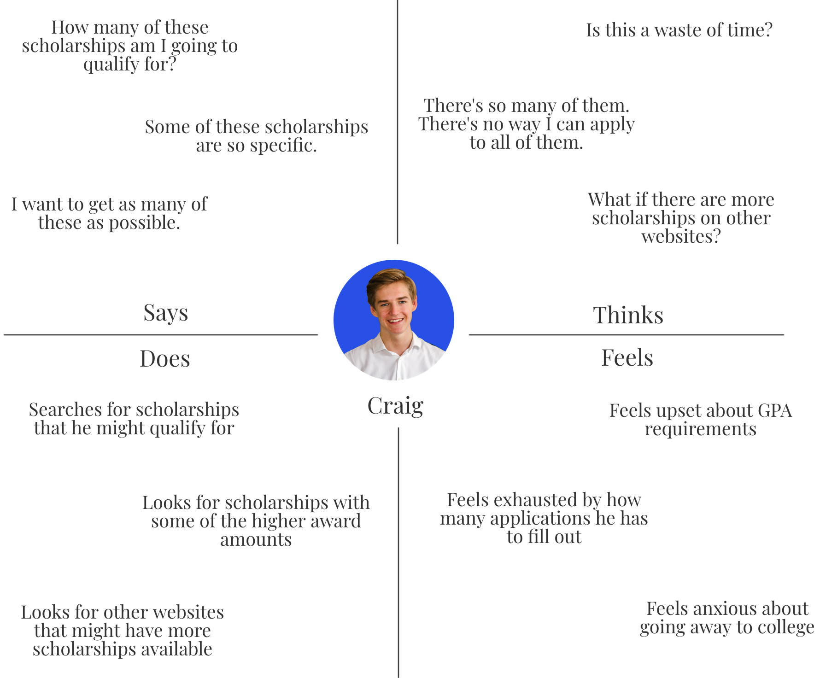Empathy Map

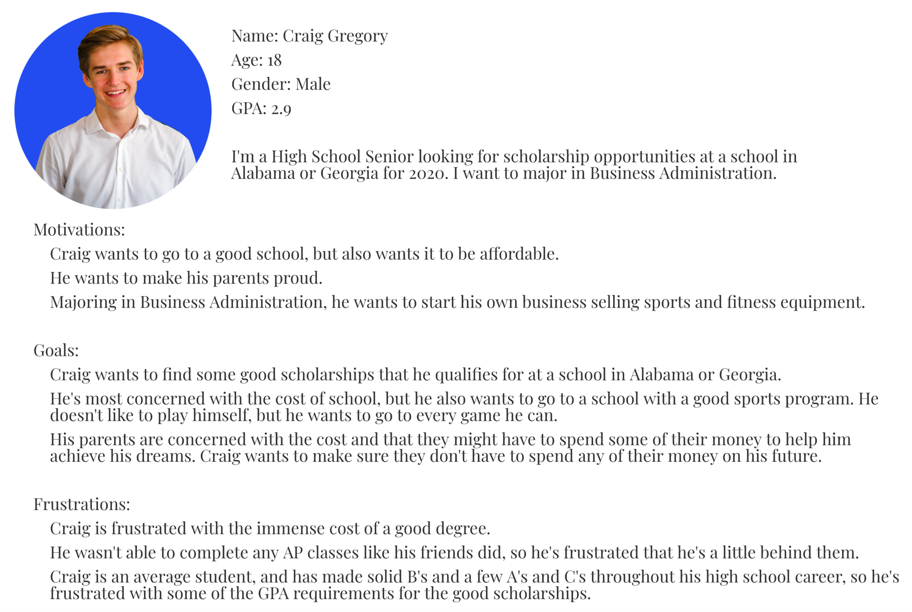Persona

HW/SW Requirements

This will be able to run on both a desktop computer (PC, Mac, etc.), any kind of tablet, and on a mobile device. The capabilities of the website would have to be slightly reduced for mobile so it’s user friendly. We would use some combination of HTML, CSS, and Javascript as well as Bootstrap to build this website.

Interface Metaphor and Interaction Type

For the interface metaphor, our website uses a logo featuring a pencil and paint brush to illicit the image of school. The name “ScholarshipU” also helps the user know exactly what they’re going to find on the website. Our website also uses the very familiar navigation bar that many other websites have.

For the interaction type, our website instructs users right on the front page on how to join and where to get more information about our company. When they go to join, they are instructed on how to join and can manipulate the text boxes in the application to put in their information. After they’ve joined, they are free to explore our website and all the scholarships we have to offer based on the information they gave us about them.

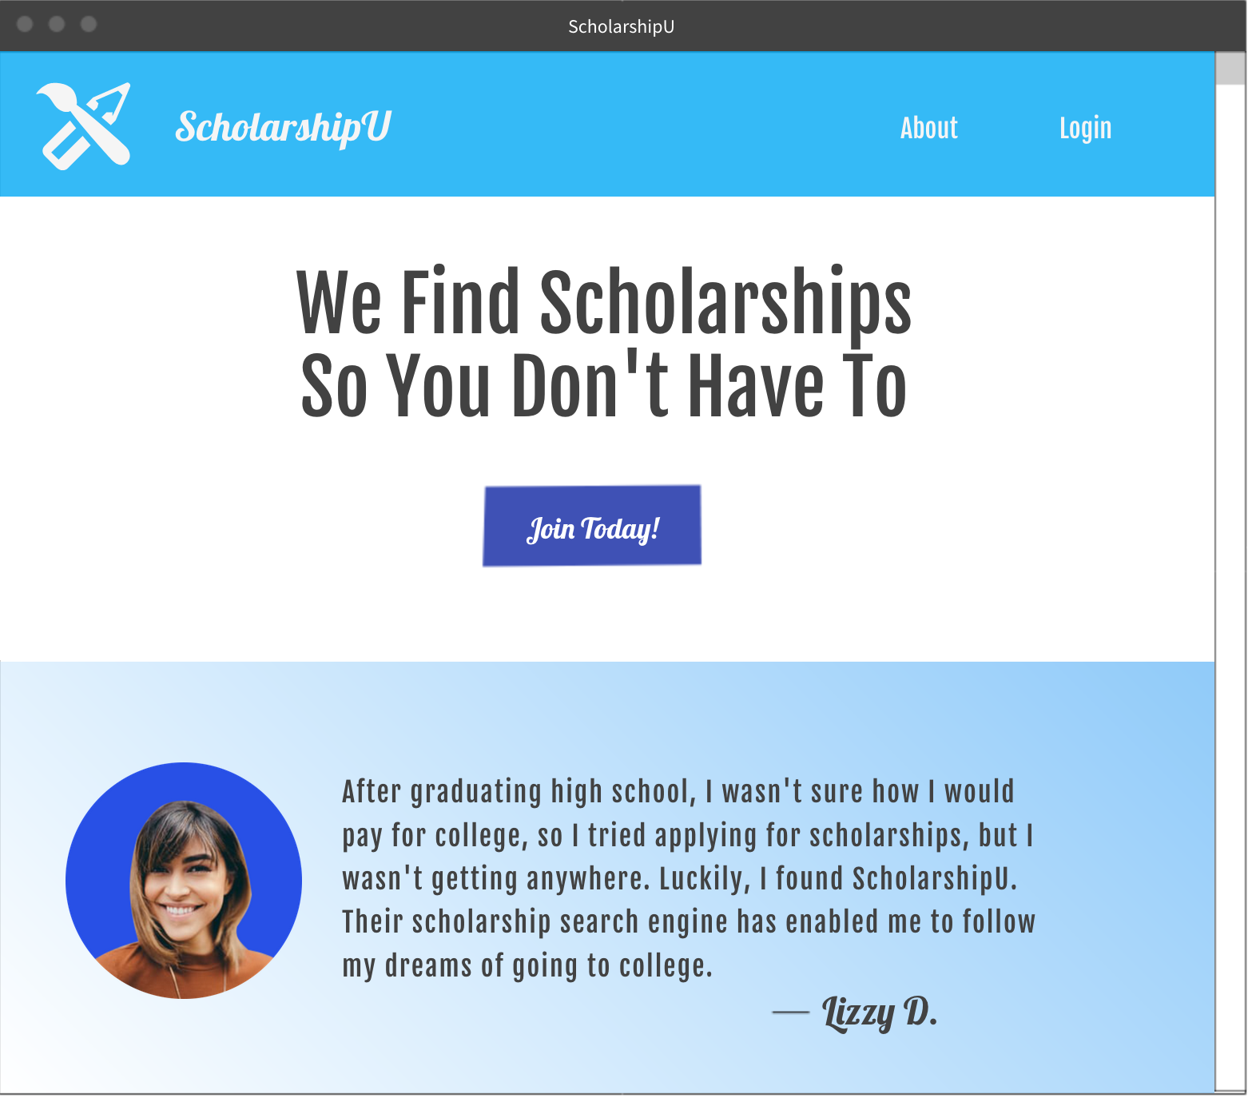Webpages

